**MANAV RACHNA UNIVERSITY, FARIDABAD**

**Department of Computer Science and Technology**

**Course: B.Tech. CSE Semester: 6 Session: Jan 2021-May 2021 Subject: Agile Technologies (CSW317B)**

Ayaam Choudhary 2K18CSUN01012 CSE6A-G1

____________________________________________________________________________________

LAB 0 Experiment

1. Install JDK (Java Development Kit) any version 1.5 or above and verify the correctness of installation.

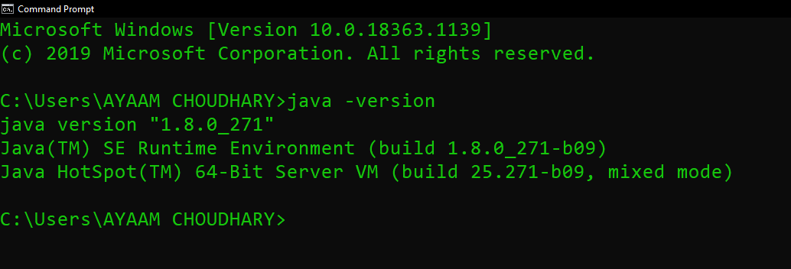

1. Write the following Java program:

(i) Write a Java program to find the minimum of a set of 10 numbers

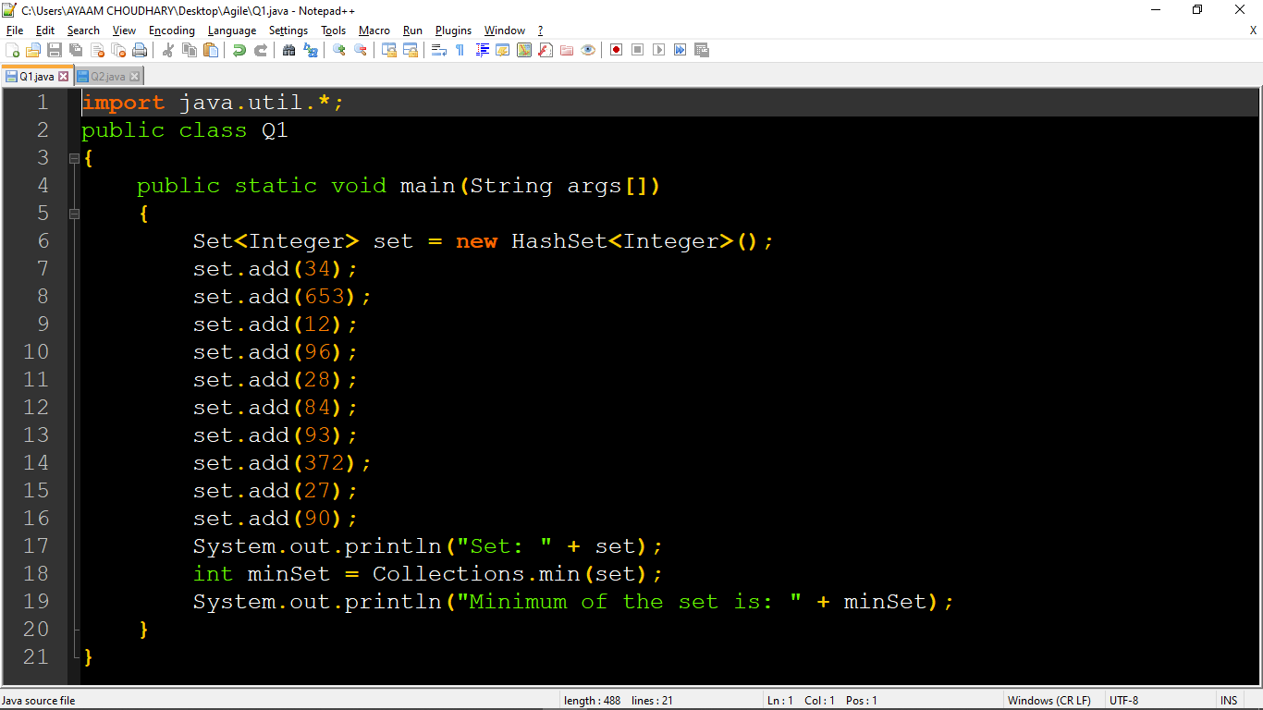

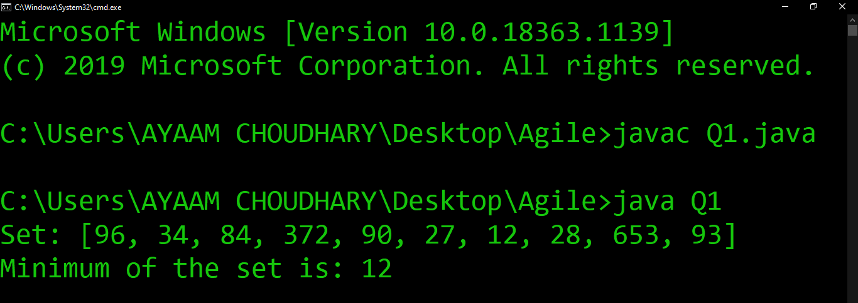

|  |
| --- |
| import java.util.*;  public class Q1  {  public static void main(String args[])  {  Set<Integer> set = new HashSet<Integer>();  set.add(34);  set.add(653);  set.add(12);  set.add(96);  set.add(28);  set.add(84);  set.add(93);  set.add(372);  set.add(27);  set.add(90);  System.out.println("Set: " + set);  int minSet = Collections.min(set);  System.out.println("Minimum of the set is: " + minSet);  }  } |

(ii) Write a Java program to compute the annual increment amount of employees using the following strategy:

* If the monthly salary of an employee is less than Rs. 1 Lakh increment should be 15 % of the annual salary
* If monthly salary is in the range of Rs.1 Lakh to Rs. 2 Lakh increment should be 10% of annual salary
* If the monthly salary is more than Rs. 2 Lakh increment should be 5% of the annual salary

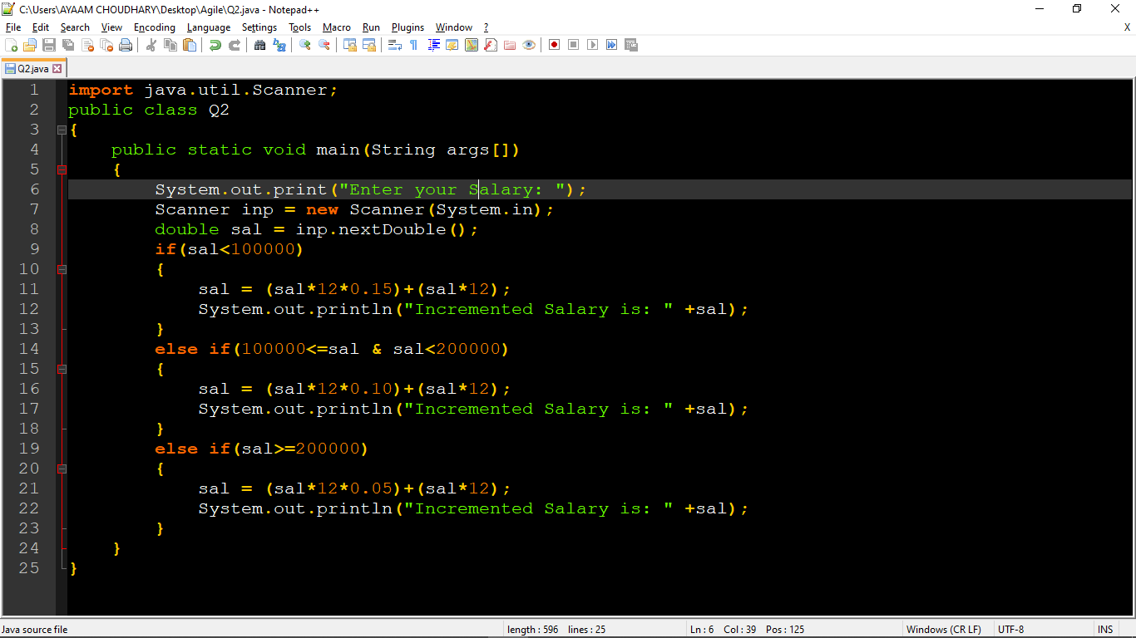

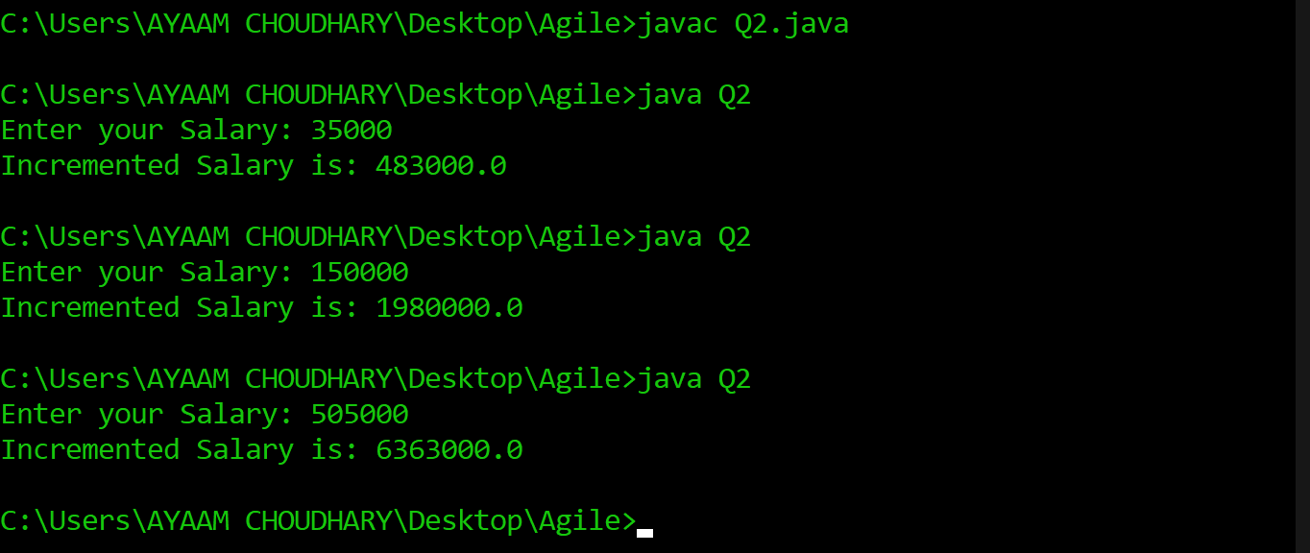

|  |
| --- |
| import java.util.Scanner;  public class Q2  {  public static void main(String args[])  {  System.out.print("Enter your Salary: ");  Scanner inp = new Scanner(System.in);  double sal = inp.nextDouble();  if(sal<100000)  {  sal = (sal*12*0.15)+(sal*12);  System.out.println("Incremented Salary is: " +sal);  }  else if(100000<=sal & sal<200000)  {  sal = (sal*12*0.10)+(sal*12);  System.out.println("Incremented Salary is: " +sal);  }  else if(sal>=200000)  {  sal = (sal*12*0.05)+(sal*12);  System.out.println("Incremented Salary is: " +sal);  }  }  } |

**LAB 1 Experiment**

1. In LAB 0 you have installed JDK version 1.5 or above (1.8 was preferred version) and verified the correctness of installation
2. Now install JUnit and setup the environment and verify the correctness of installation
3. Write JUnit Test Cases for the following programs, execute test cases and log test results:
   1. Java program which you have written in LAB 0 to find the minimum of  a set of 10 numbers

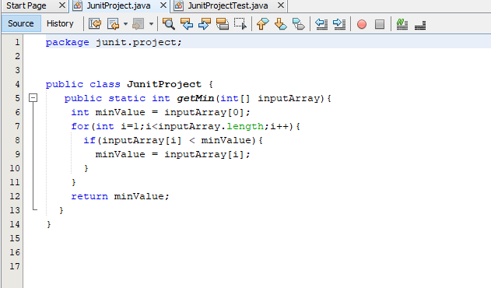

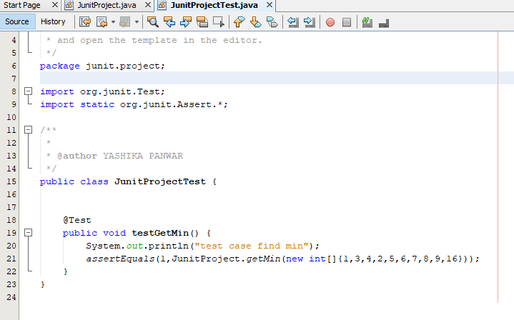

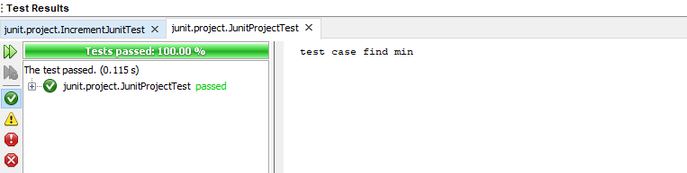

(ii) Java program which you have written in LAB 0 to compute the annual increment amount of  employees using the following strategy:

* If monthly salary of employee is less than Rs. 1 Lakh increment should be 15 % of annual salary
* If monthly salary is in the range of Rs.1 Lakh to Rs. 2 Lakh increment should be 10% of annual salary
* If  monthly salary is  more than Rs. 2 Lakh increment should be 5% of annual salary

(iii) Create JUnit Test Suite for JUnit test cases developed in above program (ii) and   execute the test cases with TestRunner and log test results

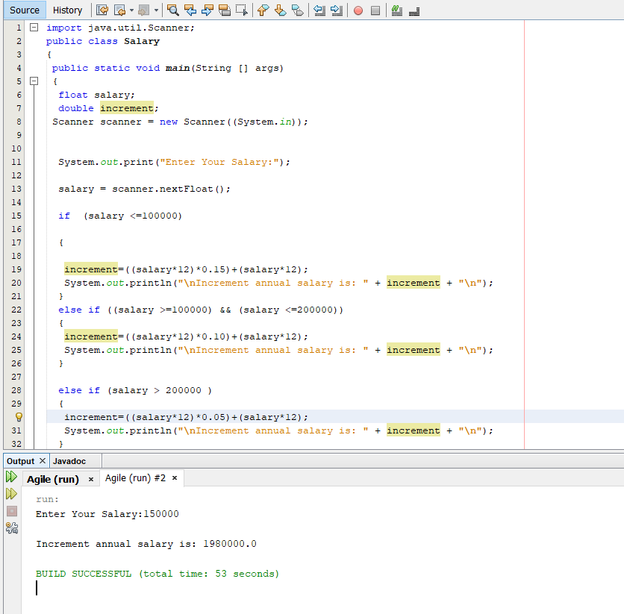

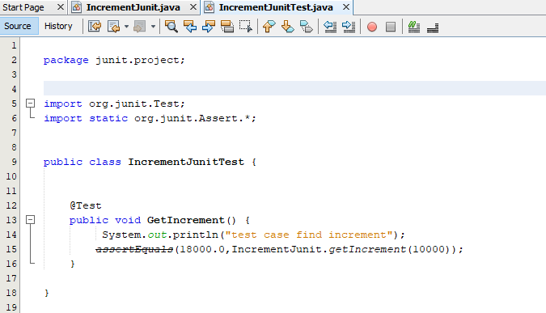

LAB 2 Experiment

**Git Experiments**

1. Install Git. Capture screen snapshot of a successful installation.

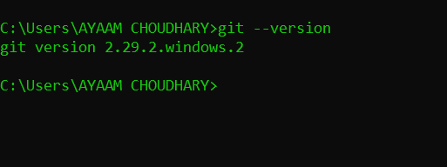

2. Execute the following Git commands and capture a screen snapshot for each command execution:

* git config

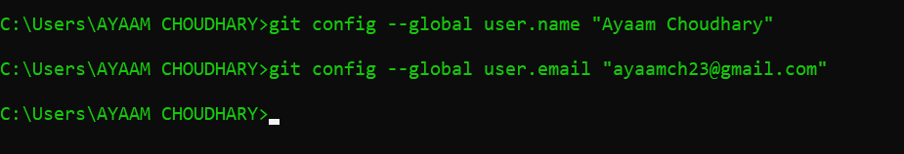

* git init

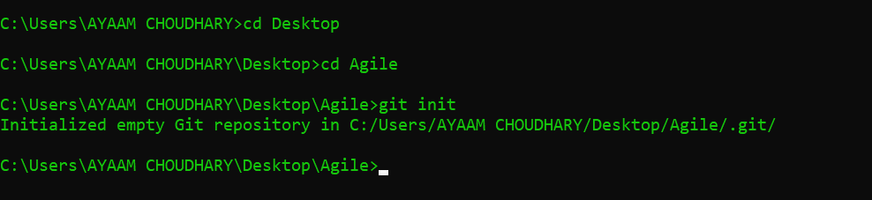

* git add

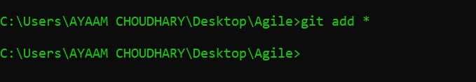

* git commit

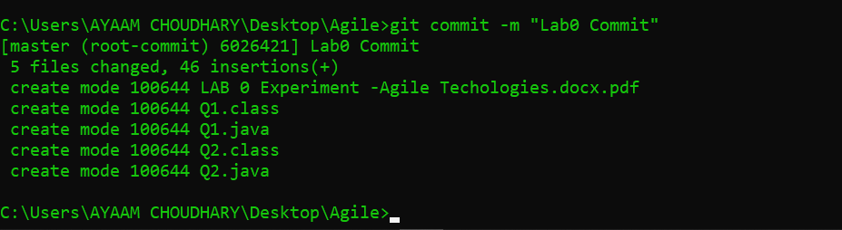

* git diff

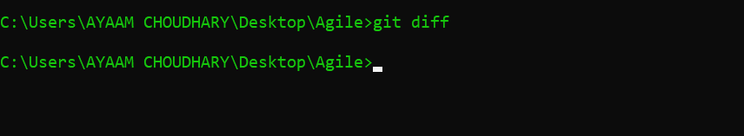

* git reset
* git status

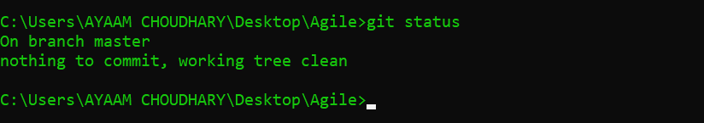

* git rm

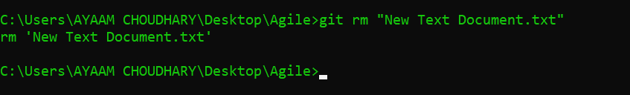

* git log

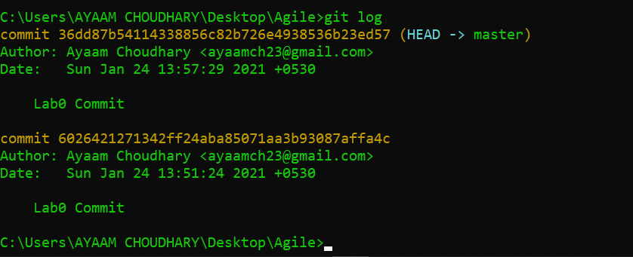

* git show

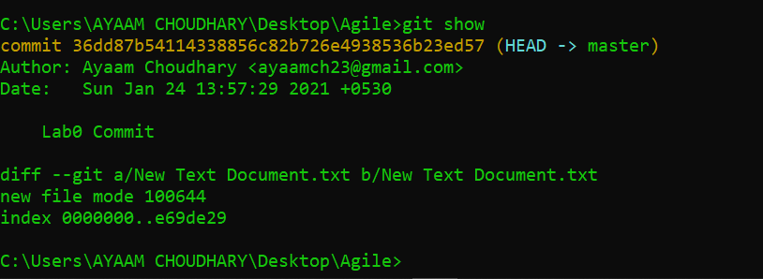

* git tag
* git checkout

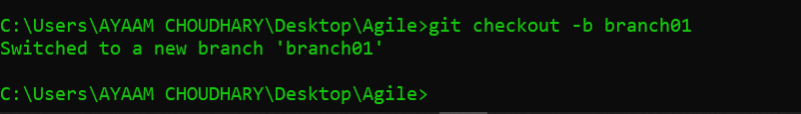

3. Create a GitHub account to have a remote repository or else you can use an existing remote repository if you already have a GitHub account. Clone the Remote Repository to a local repository. Create a new branch from the main development branch and modify some files on it. After that merge the changes to the main branch and push them to the remote repository. Use the following additional commands to achieve this. Capture screen snapshots of all Git commands execution

* git clone

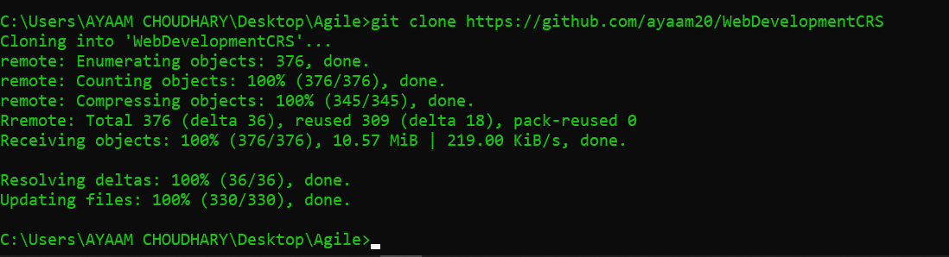

* git branch

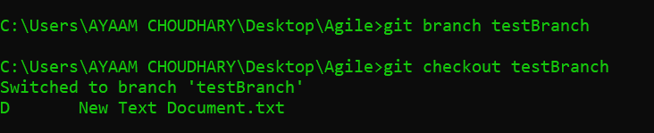

* git checkout



* git merge

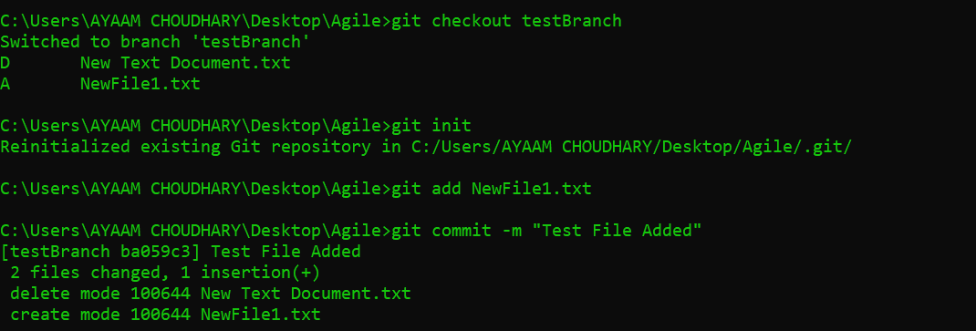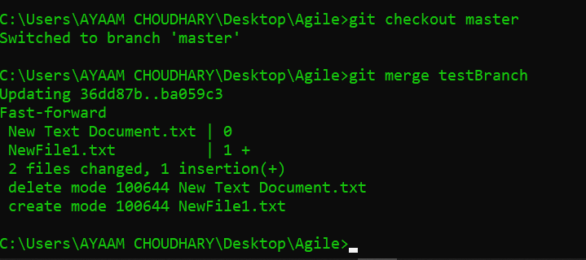

* git remote



* git push

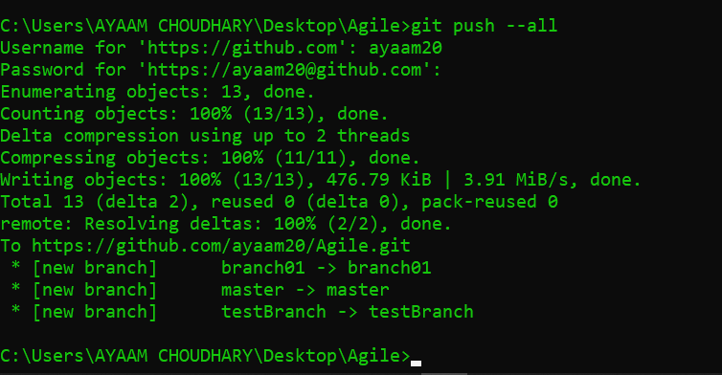

* git pull

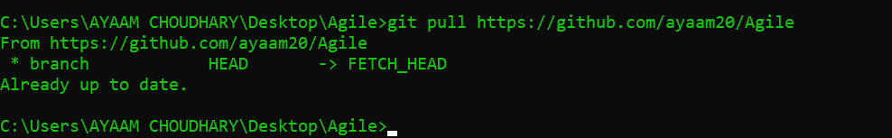

* git stash

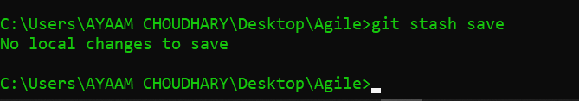

LAB 3 Experiment

**Eclipse Experiments**

1. Install Eclipse

2. Use Eclipse framework to write the HelloWorld program and run it as Java Application.

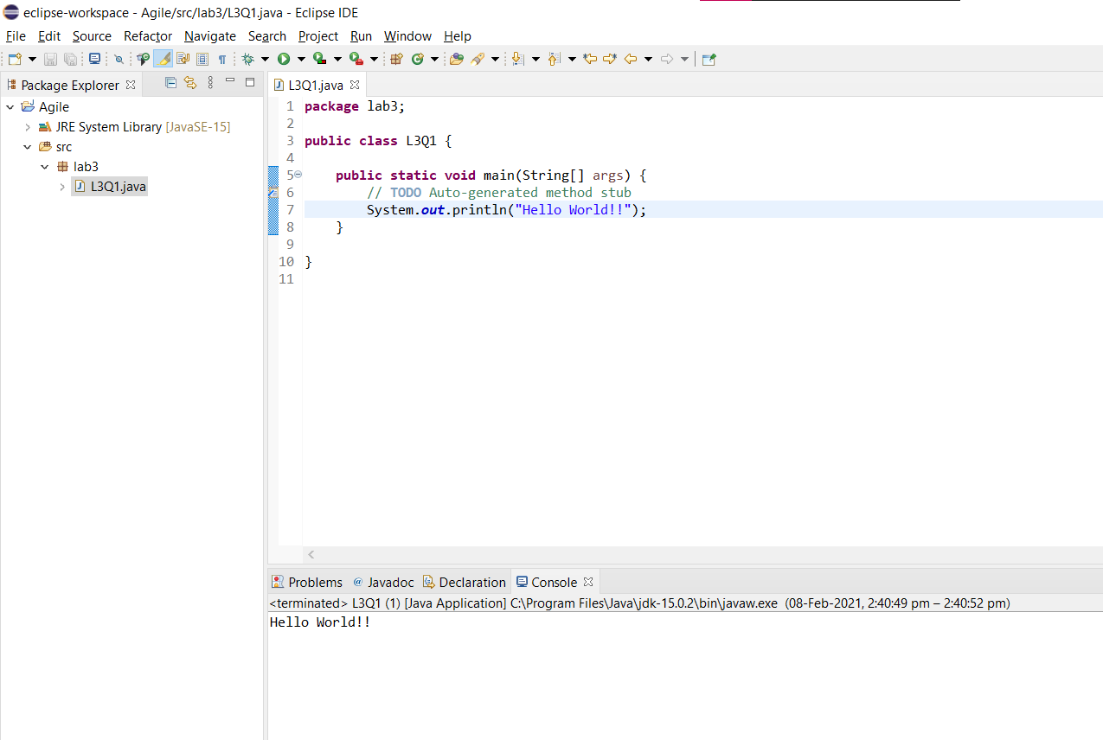

1. Access a Git repository from Eclipse. Do some file updating in Eclipse IDE and push the changes to Git Repository.

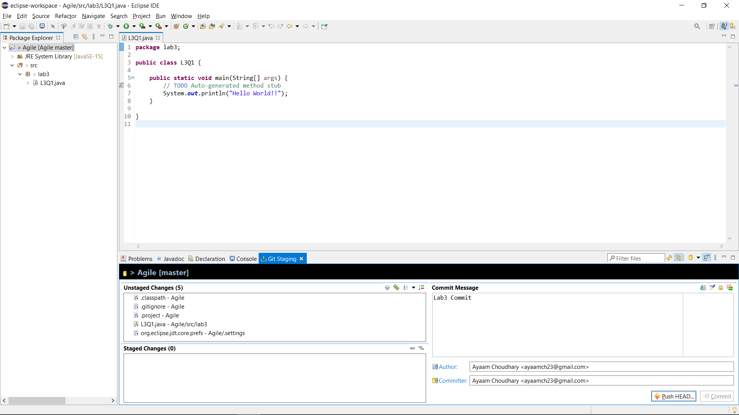

4. Run JUnit Test cases developed under JUnit Experiment from Eclipse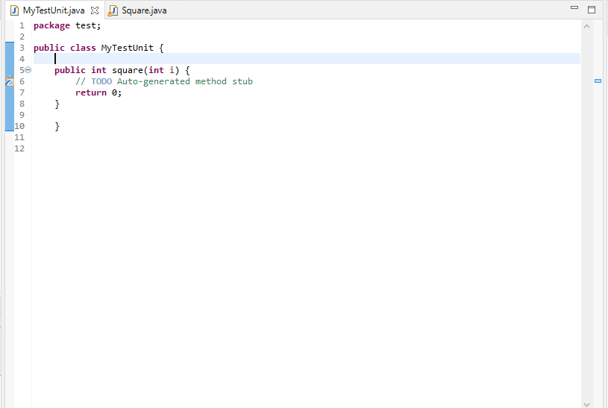

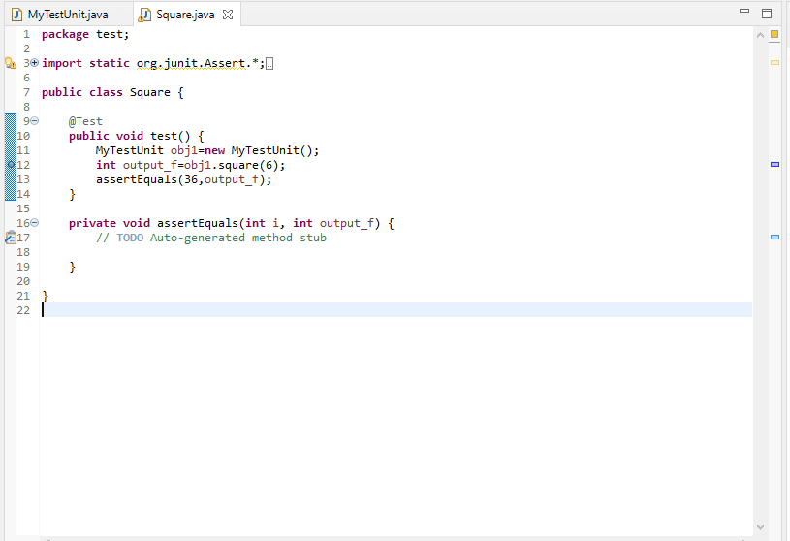

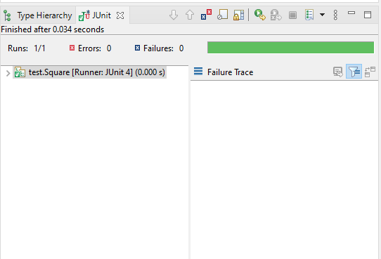

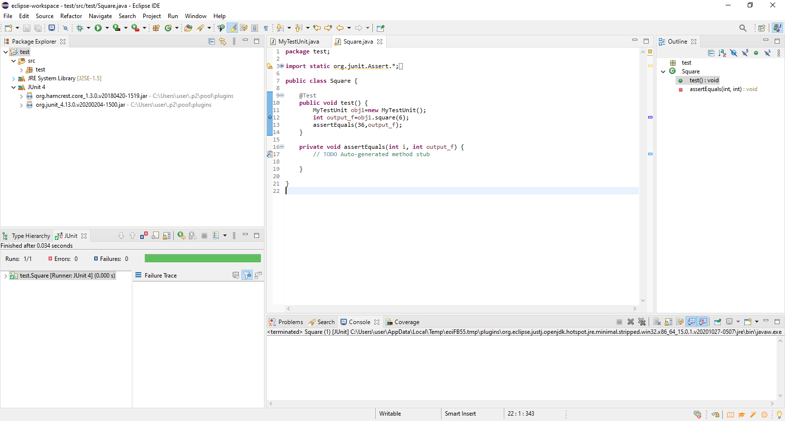

5. Capture screen snapshots of all the above 4 activities performed in Eclipse

LAB 4 Experiment

**Jenkins Experiment**

1. Install Jenkins and capture screen snapshot of verification of successful installation

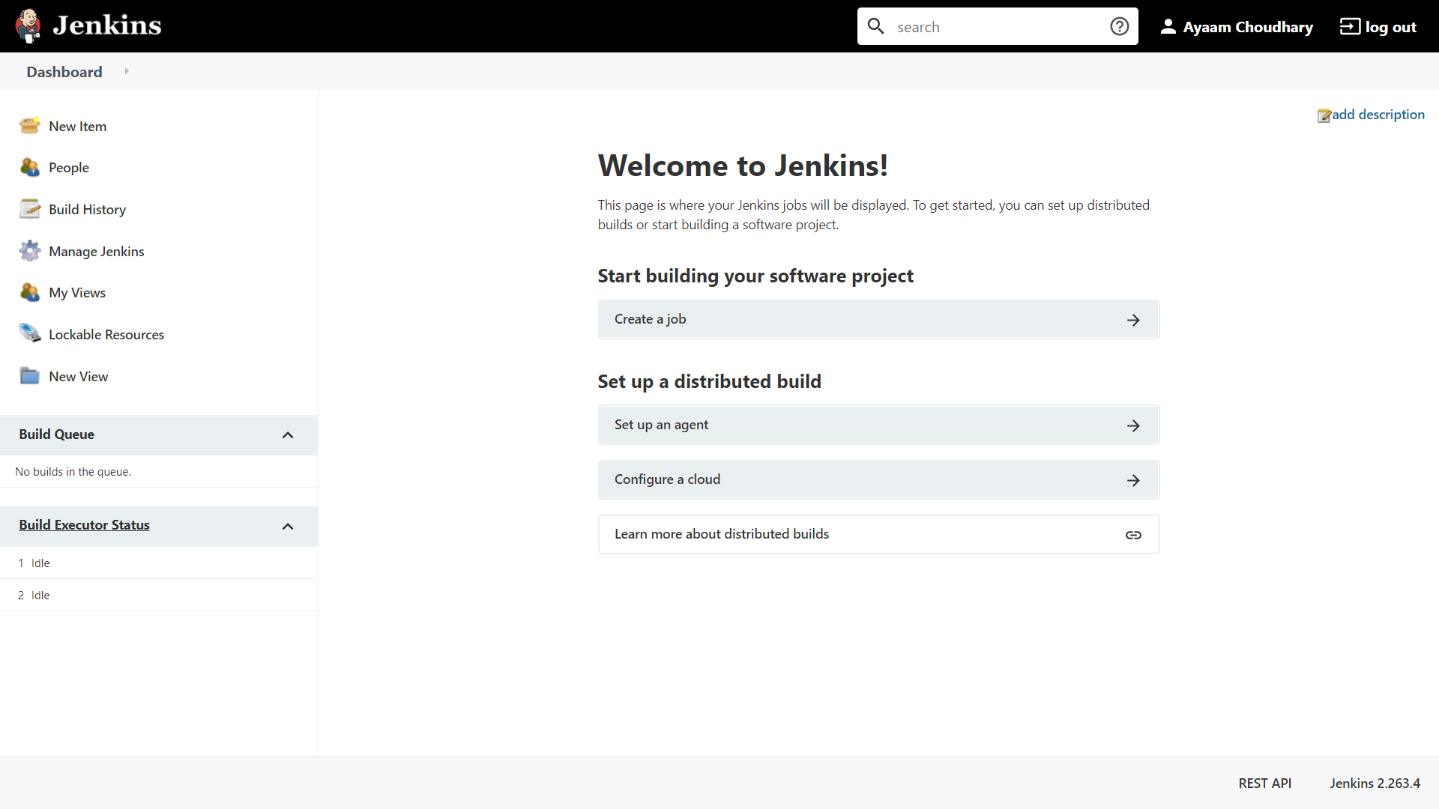

1. Do a build in Jenkins using “Execute Windows Batch Commands.” You can put commands in a batch file to compile and run JAVA programs, JUnit tesr cases etc which you have already developed in the previous lab experiments.

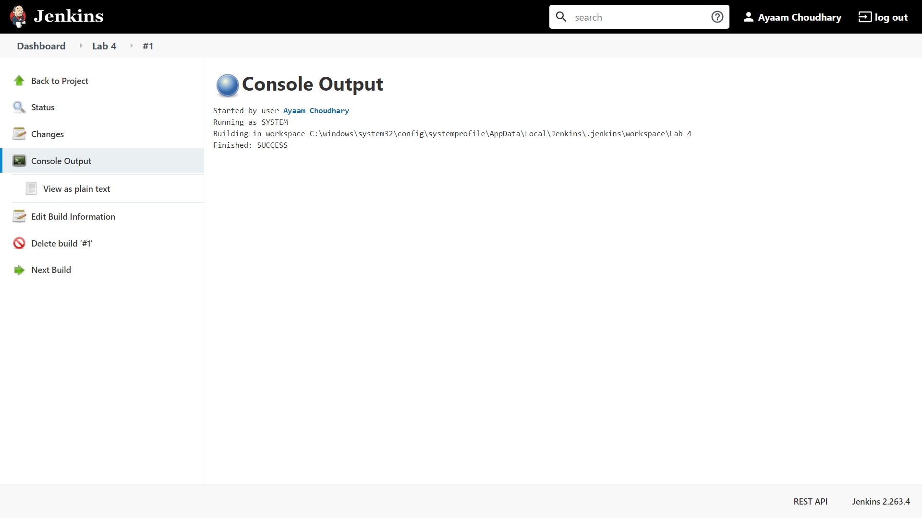

3. Capture screen snapshot of build result in Jenkins Dashboard. 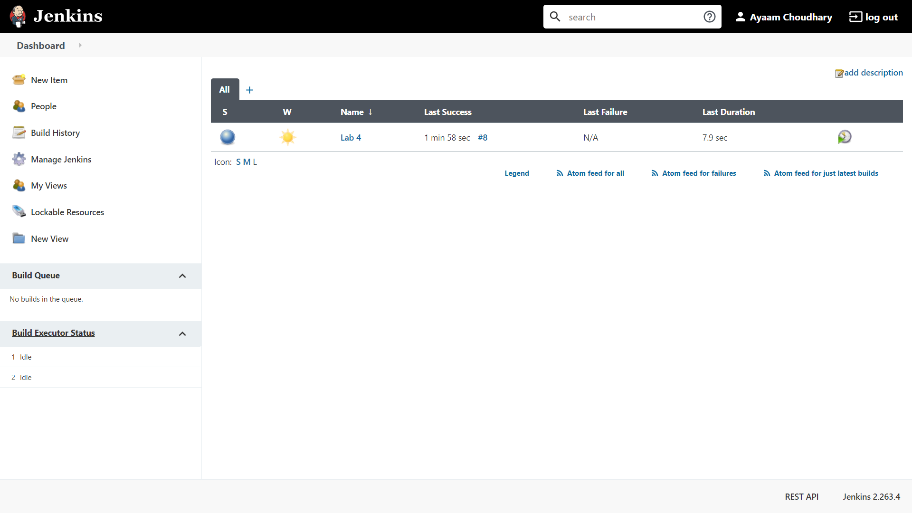

LAB 5 Experiment

**Maven Experiment**

1. Install and configure Maven and capture screen snapshot of verification of installation

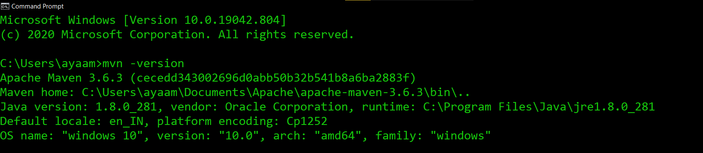

2. Create a simple POM file to do a build of small JAVA application using Maven and run the build job from Jenkins 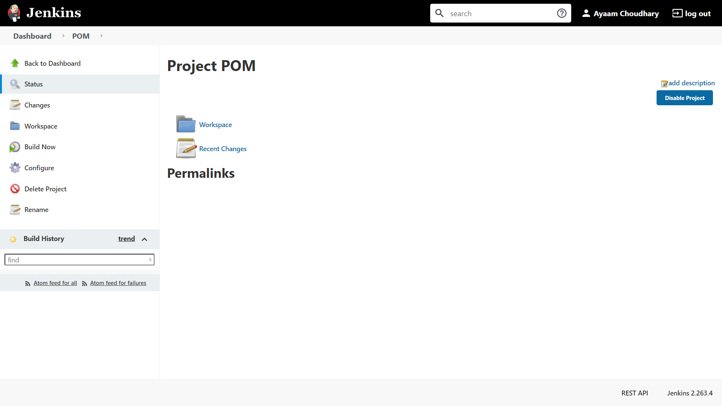

Reference Link to get help on the assignment: https://maven.apache.org/guides/getting-started/

**LAB 6 Experiment**

**Cucumber Experiment**

1. Install Cucumber by going through the step-by-step process at the following link:

<https://www.guru99.com/introduction-to-cucumber.html>

Capture screen snapshot of verification of installation

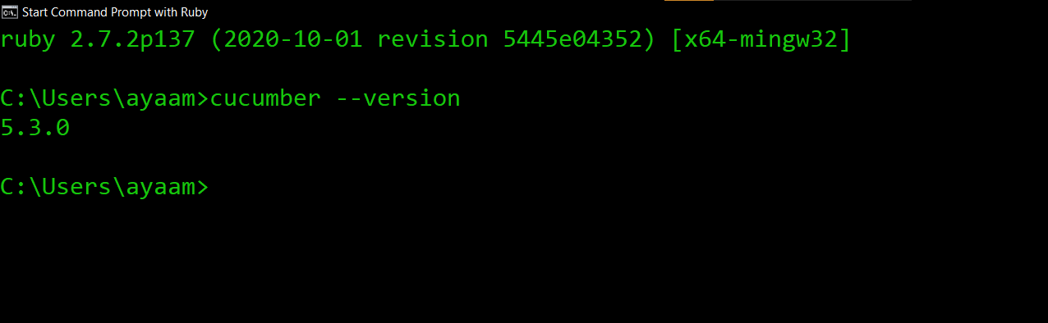

2. Write Gherkin script and create the step definition file for testing the following two small programs using Cucumber tool:

(i) Ruby program to Multiply two numbers and display the result

(ii) Ruby program for FizzBuzz game with the following features:

* + Enter an integer no.
    - If the input no is a multiple of 3 then display “Fizz”
    - If the input no is a multiple of 5 then display “Buzz”
    - If the input no is a multiple of both 3 and 5 then display “FizzBuzz”

Execute Cucumber test cases for both the above 2 programs and capture screen snapshot of execution of Cucumber test cases.